Successful non-surgical peri-implantitis therapy supported with a hypochlorite cleaning gel and cross-linked hyaluronic acid (CLEAN&SEAL).

Dr. Thomas Liechti, Dr. Thomas Gottwald

The combination of adjunctive application of a sodium hypochlorite cleaning gel in the mechanical cleaning of the implant surface with the application of a cross-linked hyaluronic acid into the cleaned wound space offers a less-invasive initial therapy option in the non-surgical treatment of peri-implant defects.

Introduction
Peri-implant inflammation presents us with a major therapeutic challenge in clinical practice. Similar to periodontitis, the main cause of the disease is the accumulation of pathogenic biofilm in the pockets around the implants, resulting in often uncontrolled tissue resorption. [Page 1997]
Due to the complexity of the implant surface, successful removal of the biofilm is very difficult in clinical practice. For this reason, less invasive non-surgical therapeutic approaches unfortunately do not lead to predictable resolution of the inflammation in most cases.[Renvert 2015]
Consequently, the standard of care is invasive surgical exposure and cleaning of the implant surface, combined with either a resective or a regenerative approach. [Schmidlin 2012, Renvert 2009, Almohandes 2019].

Our clinical treatment goal for both treatment protocols is resolution of inflammation and optimally regeneration of bone defects. Radiographic assessment of bone level and clinical improvement in BOP, PD, and REC serve as evaluation criteria. [Almohandes 2019].

To date, no treatment protocol has been established as a "standard". Basically, peri-implantitis therapy consists of a multi-step treatment sequence. [Smeets 2014]

Cleaning and decontamination
The biggest problem is still the successful removal of the biofilm and the infected granulation tissue present in the pocket. It is well known that mechanical cleaning alone and most chemical adjuvants cannot achieve complete cleaning of the implant surface and the peri-implant defect filled with infected granulation tissue, especially in a non-surgical approach. [Koo 2019, Stavropoulos 2019, Mordini 2021]
Thus, the best results are generally realized by surgical visualization of the defect and careful, multistage, and as complete as possible cleaning by mechanical instrumentation under visualization. [Heitz-Mayfield 2014, Black 2015]

A promising low-cost option for the adjuvant treatment of periodontal and peri-implant inflammation is a cleansing gel based on sodium hypochlorite (NaOCl) (PERISOLV, REGEDENT GmbH). It consists of a 0.95% NaOCl solution which is buffered with an amino acid solution before use.
It is known that the gel effectively removes biofilm, [Jurczyz 2015], even if it is on a rough implant surface [Bach 2016].
In addition, this gel exhibits a degranulating effect that can improve the cleaning of the complex implant surface and the infected pocket around the implant. [Bach 2016]
Unlike pure NaOCl, which has tissue irritating properties, PERISOLV® acts specifically on degenerated infected tissue structures.
In the treatment of peri-implant bone defects, multiple applications of the gel are recommended during mechanical treatment of the implant surface and the infected pocket around the implant to achieve better cleaning performance.
In periodontitis treatment, adjunctive use of the cleansing gel can achieve a statistically significant improvement in all measurement parameters (PD, CAL, BOP) in the nonsurgical treatment of periodontal pockets. [Iorio-Siciliano 2021]
The same is true in the closed treatment of peri-implant mucositis. [Iorio-Siciliano 2020] The incidence of exploratory bleeding (BOP) was reduced by 70% after 1 month (versus 53% in the control group without gel application). Unfortunately, this promising short-term result was not maintained stably in either group. Thus, after 6 months, only 45% of the implants in the gel group and 32% in the control group showed no signs of inflammation. For this reason, the additional use of biologics, which accelerate healing and at the same time act as a sealer to prevent recontamination with biofilm, is an option.

Support of wound and soft tissue healing with cross-linked hyaluronic acid

It is now known that hyaluronic acid (HA) supports the healing process, especially in compromised situations such as peri-implant defects. Due to its strong "adhesive effect" (1 g HA can absorb up to six liters of water) [Rajan 2013], blood is immediately bound in the defect space, stabilizing the cleansed wound area. Their bacteriostatic effect increases the protection of the wound space from recolonization by microorganisms [Carlson 2004].
In addition, hyaluronic acid significantly improves all healing processes: It leads to faster neoangiogenesis post-op and shortens wound healing. [Yildirim 2017, King 1991] Furthermore, HA stimulates true periodontal regeneration [Shirakata 2021] and even accelerates bone regeneration [Alcantara 2018, Stiller 2014].

The combination therapy of adjunctive application of sodium hypochlorite cleansing gel and cross-linked hyaluronic acid has already been successfully applied in the treatment of deep residual periodontal pockets, [Diehl 2022] so the transfer of the concept to the non-surgical treatment of peri-implant defects is obvious.

Case Report

The 49-year-old patient with no significant medical conditions (non-smoker) was referred for peri-implantitis treatment on implant 12. The implant (Straumann, BL RC 10mm) was placed 10 years ago (with bone augmentation in the apical region due to fenestration) and restored with a screw-retained crown (Figs. 1 and 2). The patient had regular DH recall alio loco. At the last recall, peri-implantitis around implant 12 was diagnosed and the patient experienced mild pain. Radiological examination showed significant bone resorption mesial to implant 12 (Fig. 3). Clinically, the probing depth was 7 mm with positive probing bleeding and little pus leakage (Fig. 4).

The treatment plan included a single, non-surgical mechanical cleaning of the pocket supported by the Clean & Seal concept: Hypochlorite cleaning gel (Perisolv, REGEDENT GmbH) and sealing of the pocket with cross-linked hyaluronic acid (Hyadent BG, REGEDENT GmbH).
First, the crown around implant 11 was removed to facilitate access to the defect. Fig. 5 shows the clinical picture after removal of the crown, with pus discharge as a sign of acute infection.
Implant treatment was performed under local anesthesia.
First, the hypochlorite preparation was prepared by mixing the two components (Fig. 6).
First, the pocket was rinsed well with H₂ O₂ (3%) and Ringer's solution, and the debris was removed with a titanium curette. Then, a little Perisolv gel was applied several times and left to act for 30 sec. The curette was then used to mechanically remove the dissolved biofilm from the implant surface (decontamination) and to separate and remove the gradually loosening granulation tissue from the native connective tissue of the pocket.
After 3-4 applications, the granulation tissue can be gradually removed in a visually controllable manner (Fig. 7-8).
In this case, after 6-7 applications, the granulation tissue appeared to be quite completely removed and the defect also no longer showed any bleeding (Fig. 9).
The pocket was then irrigated with H₂ O₂ and Ringer's solution. Finally, cross-linked hyaluronic acid (Hyadent BG, REGEDENT GmbH, Fig. 10) was placed in the pocket to seal the wound and improve wound and tissue healing. (not shown). The crown was screwed back in.
For daily care after treatment, the patient was instructed as follows: During the first week, toothbrushing and interdental cleaning around the implant should be avoided in order not to mechanically disturb the stabilization of the blood coagulum in the pocket. To disinfect the wound area, rinse 2-3 times daily with a 0.2% CHX solution. In the second week, gentle cleaning is performed with a toothbrush, and from the third week onwards, interdental brushes are used again.
The healing process was free of complications and largely painless. Fig. 11 shows the situation at the follow-up appointment after 2 months. The gingiva around implant 12 is clinically tight and free of inflammation. In order not to impair the body's own potential for regeneration of the adjacent tissues, probing of the pocket is not performed for six months. Radiologically, there are already signs of incipient densification of the marginal bone.
After 6 months, the clinical findings of the soft tissues remain firm and free of inflammation (Fig. 13). The radiograph shows advanced regeneration of the bone defect (Fig.14).

Summary

The combination of implant decontamination using a hypochlorite-based cleaning gel and "sealing" the cleaned pocket with cross-linked hyaluronic acid effectively improves the mechanical, non-surgical treatment of mucositis or peri-implantitis therapy.
Without exception, all cases treated in this way in our practice to date have shown a marked reduction in clinical inflammation and radiologically at least a tendency toward spontaneous bone regeneration.
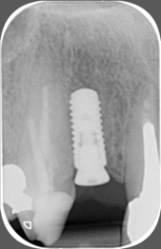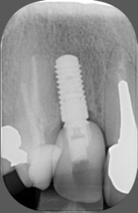 | Fig. 1/2: Radiological image after implantation and after insertion of the crown.
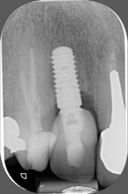 | Fig. 3: Pronounced bone defect mesial to implant 12.
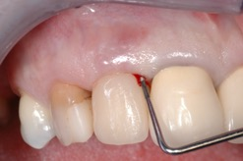 | Fig. 4: Initial clinical situation:  ST 7 mm, BOP+.
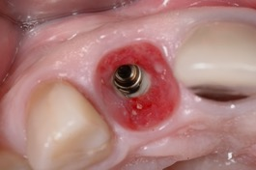 | Fig. 5: Situation after removal of the crown from implant 12 with pus exit.
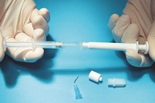 | Fig. 6: Preparation of PERISOLV: mixing of the two components.
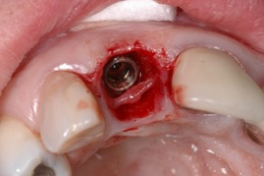 | Fig. 7: After repeated application, the granulation tissue can be removed in toto
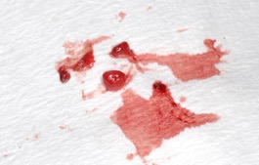 | Fig. 8: Removed granulation tissue.
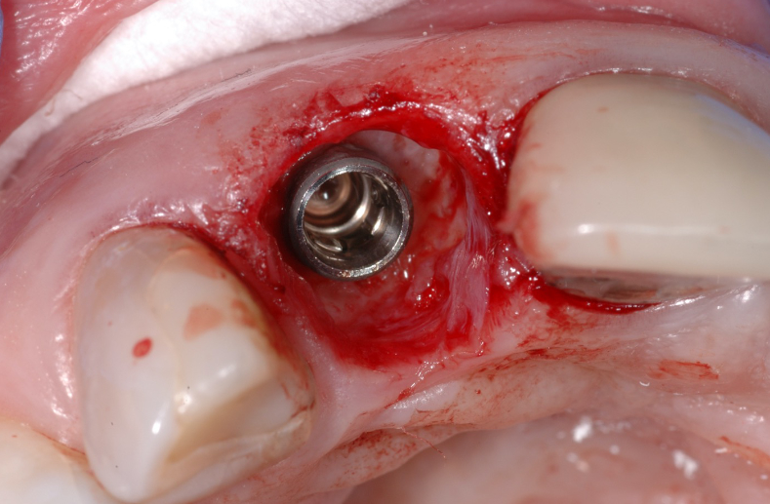 | Fig. 9: Visual control of the most complete removal of granulation tissue possible at the end of treatment.
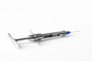 | Fig. 10: Cross-linked hyaluronic acid hyaDENT BG for sealing the cleaned pocket.
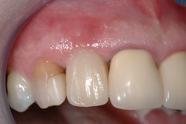 | Fig. 11: Follow-up after 2 months: asymptomatic, gingiva tight, no inflammation
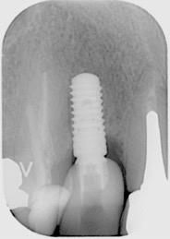 | Fig. 12: X-ray image after 2 months with incipient bone thickening mesially of implant 12.
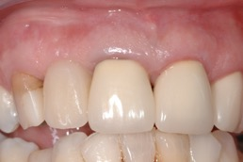 | Fig. 13: Follow-up after 6 months: asymptomatic, gingiva tight.
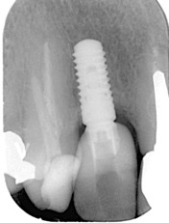 | Fig. 14: X-ray image after 6 months with extensive bone regeneration mesial implant 12.

LITERATURE

Alcântara CEP, Castro MAA, Noronha MS, Martins-Junior PA, Mendes RM, Caliari MV, Mesquita RA, Ferreira AJ. Hyaluronic acid accelerates bone repair in human dental sockets: a randomized triple-blind clinical trial. Braz Oral Res. 2018;32:e84.
Almohandes, A.; Carcuac, O.; Abrahamsson, I.; Lund, H.; Berglundh, T. Re-osseointegration following reconstructive surgical therapy of experimental peri-implantitis. A pre-clinical in vivo study. Clin. Oral Implant. Res. 2019, 30, 447-456.
Bach G, Müller C. Basic evaluation of an antimicrobial gel for peri-implantitis treatment. Implants
2016;1:6-14.
Carlson GA, Dragoo JL, Samimi B, Bruckner DA, Bernard GW, Hedrick M, et al. Bacteriostatic properties of biomatrices against common orthopaedic pathogens. Biochem Biophys Res Commun 2004; 321: 472-478.
Diehl D, Friedmann A, Liedloff P, Jung RM, Sculean A, Bilhan H. Adjunctive Application of Hyaluronic Acid in Combination with a Sodium Hypochlorite Gel for Non-Surgical Treatment of Residual Pockets Reduces the Need for Periodontal Surgery-Retrospective Analysis of a Clinical Case Series. Materials (Basel). 2022 Sep 20;15(19):6508.
Heitz-Mayfield, L.J.; Mombelli, A. The therapy of peri-implantitis: A systematic review. Int. J. Oral Maxillofac. Implant. 2014, 29, 325-345.
Iorio-Siciliano V, Blasi A, Stratul SI, Ramaglia L, Sculean A, Salvi GE, Rusu D. Anti-infective therapy of peri-implant mucositis with adjunctive delivery of a sodium hypochlorite gel: a 6-month randomized triple-blind controlled clinical trial. Clin Oral Investig. 2020 Jun;24(6):1971-1979.
Iorio-Siciliano V, Ramaglia L, Isola G, Blasi A, Salvi GE, Sculean A. Changes in clinical parameters following adjunctive local sodium hypochlorite gel in minimally invasive nonsurgical therapy (MINST) of periodontal pockets: a 6-month randomized controlled clinical trial. Clin Oral Investig. 2021 Sep;25(9):5331-5340.
Jurczyk K, Nietzsche S, Ender C, Sculean A, Eick S. In vitro activity of sodium-hypochlorite gel on bacteria associated with periodontitis. 2015: doi:10. 1007/ s00784-016-1711-9.
King SR, Hickerson WL, Proctor KG. Beneficial actions of exogenous hyaluronic acid on healing. Surgery 1991;109(1):76-84.
Koo, K.T.; Khoury, F.; Keeve, P.L.; Schwarz, F.; Ramanauskaite, A.; Sculean, A.; Romanos, G. Implant Surface Decontamination by Surgical Treatment of Periimplantitis: A Literature Review. Implant Dent. 2019, 28, 173-176.
Mordini L, Sun N, Chang N, De Guzman JP, Generali L, Consolo U. Peri-implantitis Regenerative Therapy: A Review. Biology (Basel). 2021 Aug 13;10(8):773. doi: 10.3390/biology10080773.
Page RC, Kornman KS. The pathogenesis of human periodontitis: an introduction. Periodontol 2000. 1997 Jun;14:9-11.
Rajan P, Dusanapudi LN, Kumar CS, Nair D. Hyaluronic acid - a simple, unusual polysaccharide: A potential mediator for periodontal regeneration. Universal Research Journal of Dentistry. 2013; 3: 113.
Renvert, S.; Polyzois, I.; Maguire, R. Re-osseointegration on previously contaminated surfaces: A systematic review. Clin. Oral Implant. Res. 2009, 20 (Suppl. 4), 216-227.
Renvert, S.; Polyzois, I.N. Clinical approaches to treat peri-implant mucositis and peri-implantitis. Periodontol. 2000 2015, 68, 369-404.
Schmidlin PR, Sahrmann P, Ramel C, Imfeld T, Müller J, Roos M, Jung RE. Peri-implantitis prevalence and treatment in implant-oriented private practices: A cross-sectional postal and Internet survey. Schweiz Monatsschr Zahnmed 2012;122:1136-1144.
Schwarz F, Sculean A, Engebretson SP, Becker J, Sager M. Animal models for peri-implant mucositis and peri-implantitis. Periodontol 2000 2015;68:168-181.
Shirakata Y, Imafuji T, Nakamura T, Kawakami Y, Shinohara Y, Noguchi K, Pilloni A, Sculean A. Periodontal wound healing/regeneration of two-wall intrabony defects following reconstructive surgery with cross-linked hyaluronic acid-gel with or without a collagen matrix: a preclinical study in dogs. Quintessence Int. 2021;0(0):308-316.
Smeets R, Henningsen A, Jung O, Heiland M, Hammächer C, Stein JM. Definition, etiology, prevention and treatment of peri-implantitis - a review Head & Face Medicine 2014,10:34.
Stavropoulos, A.; Bertl, K.; Eren, S.; Gotfredsen, K. Mechanical and biological complications after implantoplasty-A systematic review. Clin. Oral Implant. Res. 2019, 30, 833-848.
Stiller M, Kluk E, Bohner M, Lopez-Heredia MA, Müller-Mai C, Knabe C. Performance of β-tricalcium phosphate granules and putty, bone grafting materials after bilateral sinus floor augmentation in humans. Biomaterials. 2014;35(10):3154-3163.
Yildirim S, Özener HÖ, Doğan B, Kuru B. Effect of Topically-Applied Hyaluronic-Acid on Pain and Palatal Epithelial Wound Healing: An Examiner-Blind, Randomized, Controlled Clinical Trial. J Periodontol. 2017;15:1-14.

